**Operations Management**

* 1. **What is operations management?**

**Operations management** = the activity of managing the resources that create and deliver services and products

**Operations function** = part of the organization responsible for operations management.

**Operations managers** = the people who have a responsibility for managing some/all of the resources that comprise the operations function

**Operations principle** = “all organizations have operations that produce some mix of services and products”

**Agenda of operation managers:** Every organization’s operation and offering should be innovative, focus on customer satisfaction, invest in the development of their staff, and play a positive role in fulfilling their social and environmental responsibilities

**Operations in the organization**

The core functions of any organization are: **marketing** function (including sales), **product/service development** function, **operations** function

**The marketing function** = responsible for **positioning and communicating** the organization’s services and products **to its markets** in order to **generate customer demand**

**The product/service development function** = responsible for **developing new and modified** services and products in order to generate **future** customer demand

**The operations function** = responsible for the **creation and delivery** of services and products **based on customer demand**. Can be seen as comprising all the activities necessary for the day-to-day fulfilment of customer requests within the constraints of social and environmental sustainability

Includes sourcing services and products from suppliers and delivering services and products to customers

**Support functions** = enable the core functions to operate effectively (includes accounting, technical, human resources functions etc). Operations management’s responsibility to support functions is to make sure that they understand operations’ needs and help them satisfy those

* 1. **Why is operations management important in all types of organizations?**

Any business that creates something must use resources to do so and must have an operations activity. Not-for-profit organizations also use their resources to create and deliver services, not to make a profit, but to serve society in some way

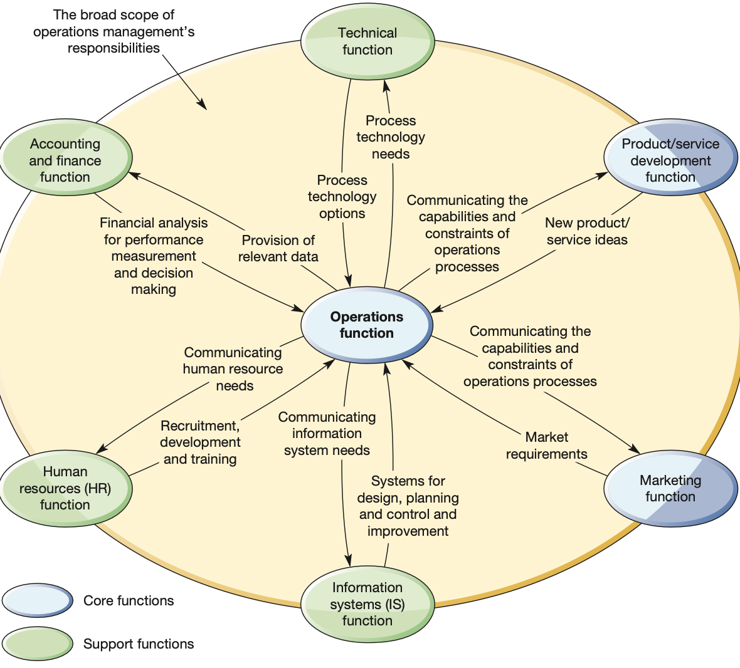

Operations management uses resources to create outputs that fulfil defined market requirements

**Operations management in the smaller organization**

Large companies may have the resources to dedicate individuals to specialized tasks, but smaller companies often cannot → people may have to do different jobs as the need arises

**Informal structure** can allow the company to respond quickly as opportunities or problems present themselves. However, decision making can become confused as individuals’ roles overlap

**Small companies** may have the exactly same operations management issues as large ones but they can be more difficult to separate from the mass of other issues in the organization

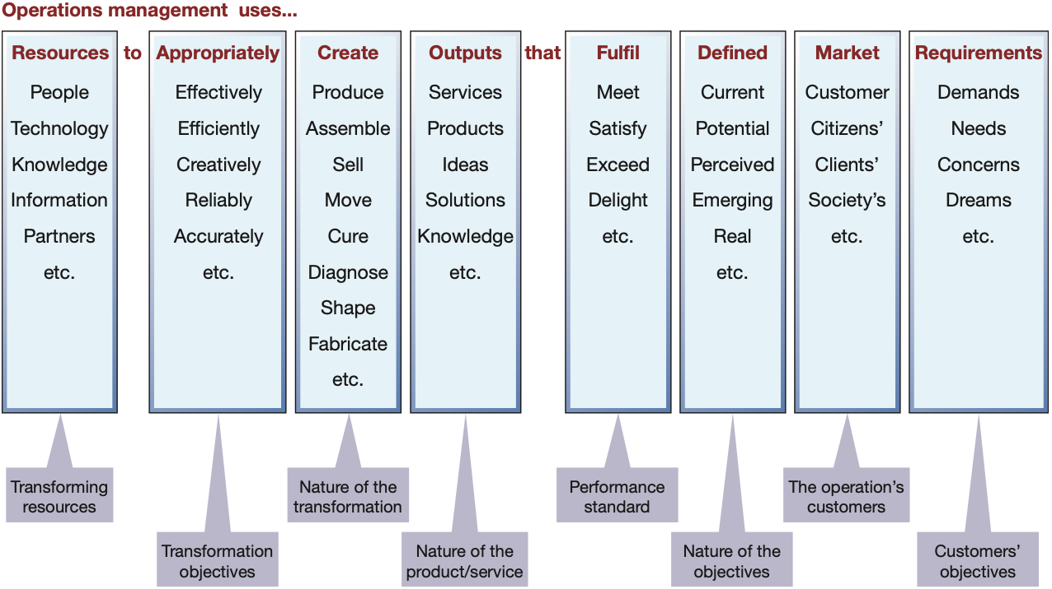

**Operations management in the smaller organization**

In all organizations, operations have to take the same decisions:

* How to create and deliver services and products
* Invest in technology
* Contract out some of their activities
* Devise performance measures
* Improve their operations performance

The **strategic objectives of not-for-profit organizations** may be more complex and involve a greater emphasis on political, economic, social or environmental objectives → may be a greater chance of operations decisions being made under conditions of conflicting objectives

**The new operations agenda**

Operations managers have had to adjust their activities to cope in the following areas:

1. **New technologies**
   1. In both manufacturing and service industries, **process technologies** are changing so fast that it is difficult to predict exactly what their effect will be. They are likely to have a dramatic effect, radically altering the operating practices of almost all types of operation
2. **Different supply arrangements**
   1. Some globalized supply markets are opening up new sourcing options, other supply chains have become increasingly risky. Opportunities for cost savings must be balanced against supply vulnerability and ethical issues
3. **Increased emphasis of social and environmental issues**
   1. Customers, staff, investors have been developing an increased ethical and environmental sensitivity, leading to operations having to change the way they conceive and create their products and services.
   2. There is greater expectation about the ethical treatment of all an operation’s stakeholders, including customers, the workforce, suppliers and society in general
   3. **What is the input-transformation-output process?**

All operations create and deliver services and products by changing inputs into outputs using an input-transformation-output process, which is the basis of all operations

Operations take in a set of **input resources** that are used to transform something or are transformed themselves, into outputs of services and products

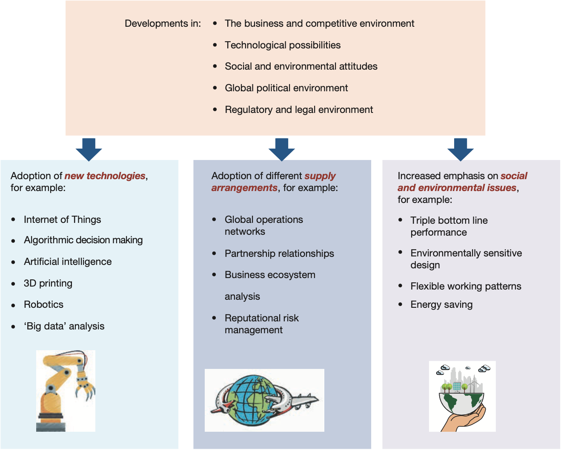

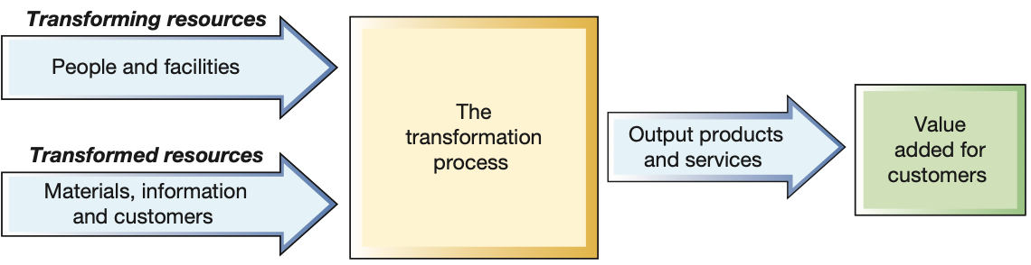

**Inputs to the process – transformed resources**

**Transformed resources** = one set of inputs to any operation’s processes and are the resources that are treated, transformed or converted in the process. Usually a mixture of:

* **Materials** = operations that process materials could do so to transform their physical properties (most manufacturing operations are like this). Other operations process materials to change their location (delivery companies for example). Some like retail operations change the possession of the materials, and lastly some operations store materials (warehouses)
* **Information** = operations that process information could do so to transform their informational properties (i.e. accountants). Some change the possession of the information (market research, social media operation). Some store the information (libraries, archives) and lastly some change the location of the information (telecompanies)
* **Customers** = operations that process customers might change their physical properties in a similar way to materials processors (hairdressers). Some store customers (hotels). Transform the location of their customers (airlines) and some change their physiological state (hospitals). Other than being passive items, customers can be active such as creating the atmosphere in a restaurant

**Inputs to the process – transforming resources**

**Transforming resources** = resources that act upon the transformed resources, come in two types: **facilities** (buildings, equipment, process technology of the operation) and **staff** (people who operate, maintain, plan and manage the operation)

**Front- and back-office transformation**

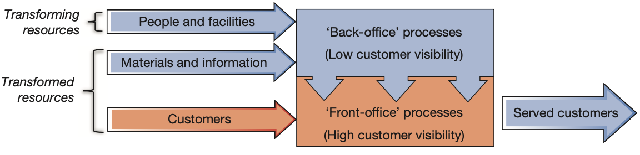

**Front office** = processes that interact with customers

**Back office** = processes that have little/no direct contact with customers but perform activities that support the front office in some way

**Outputs from the process**

**Products or services, or does it matter?**

**Product** = physical and tangible thing

**Service** = activity that usually involves interaction with a customer or something representing the customer. The resources that carry out these activities may be tangible but not the service they provide

The accepted distinction between products and services abbreviated to **IHIP**

* **Intangibility** – they are not physical items
* **Heterogeneity** – difficult to standardize because each time a service is delivered, it will be different because the needs and behavior of customers will vary
* **Inseparability** – their production and consumption are simultaneous
* **Perishability** – cannot be stored because they have a short shelf life, may even perish in the very instant of their creation

**Most operations produce outputs somewhere on a spectrum of the IHIP characteristics**

Most operations produce outputs that are in-between tangible products and intangible services

* **Intangibility** – difficult to define the boundary of the less tangible elements of service → becomes important to manage customers’ expectations as to what the service comprises
* **Heterogeneity** – every service is different and difficult to standardize. Customers could ask for elements of service that are difficult to predict and may be outside the operation’s capabilities. Cost efficiencies become difficult and staff must be trained to cope with a wide variety of requests
* **Inseparability** – production and consumption are simultaneous, to meet all demand, operations must have sufficient capacity in place to meet demand as it occurs. Customer guidance can reduce the need for contact (i.e. the use of FAQ:s on a website)
* **Perishability** – an operation’s output is difficult to store and ceases to have a value after a relatively short time → matching capacity with demand is important to avoid either underutilized resources or lost revenue

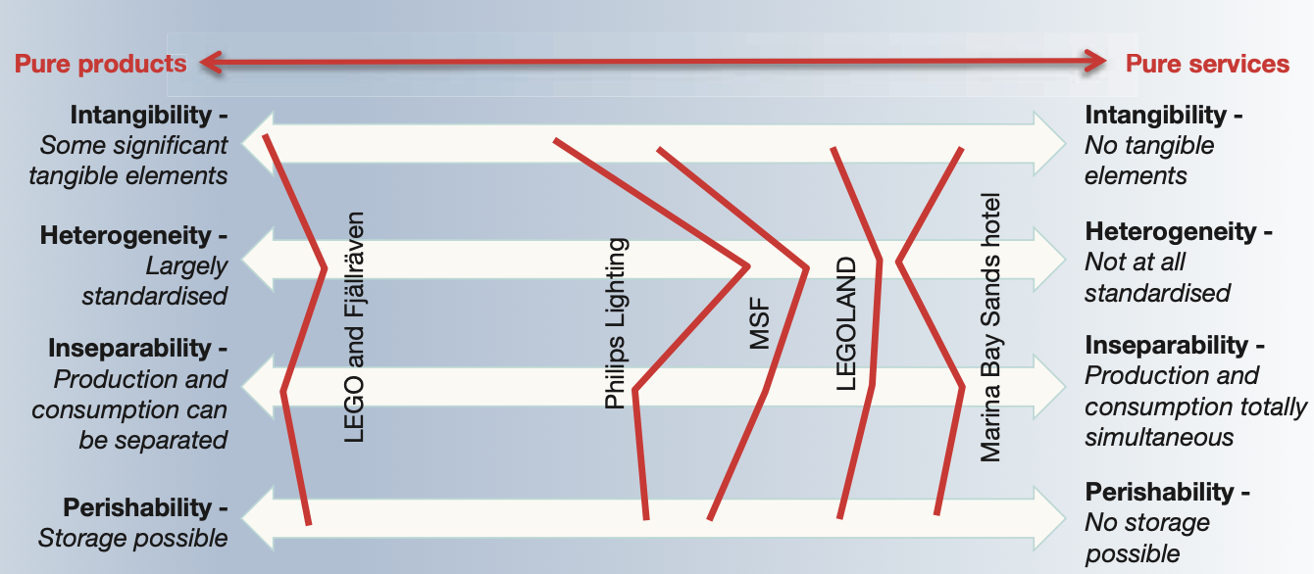

**Services and products are merging (and changing)**

**Service dominant logic** = idea that all operations should be seen as **offering value propositions through service.** Service is seen as the fundamental basis of exchange, physical goods are simply the distribution of mechanisms for the provision of service and that the customer is always the co-creator of value

**Customers are part of the process – co-creation and co-production**

It is not unusual for customers to play a central part in how they derive value from an operation’s output (i.e. take themselves around a supermarket)

**Co-creation/production** = co-creation implies customer involvement in the design of a product/service, co-production is the production of a pre-designed offering. Often a degree of customer involvement, engagement, participation or collaboration within an operation

**Servitisation**

**Servitisation** = indicates how operations (once considered themselves exclusively producers of products) are becoming more service-conscious. Involves firms developing the capabilities they need to provide services and solutions that supplement their traditional product offerings

**Customers**

**B2B and B2C**

**Business to business operations** (B2B) = provide their products or services to other businesses

**Business to consumer operations** (B2C) = provide their products or services direct to the consumers who are the ultimate users of the outputs from the operation

Operations serving both businesses and customers will be faced with different kinds of concerns and probably be organized in different ways. Understanding of customers is always important, such as their needs, both current and potential, for the operations

**SIPOC analysis**

**SIPOC** = stands for suppliers, inputs, process, outputs and customers. It is a method of formalizing a process at a relatively general rather than a detailed level. Its **advantage** is that it helps all those involved in the process to understand what it involves and where it fits within the business. It can also prompt important questions that can sometimes be overlooked

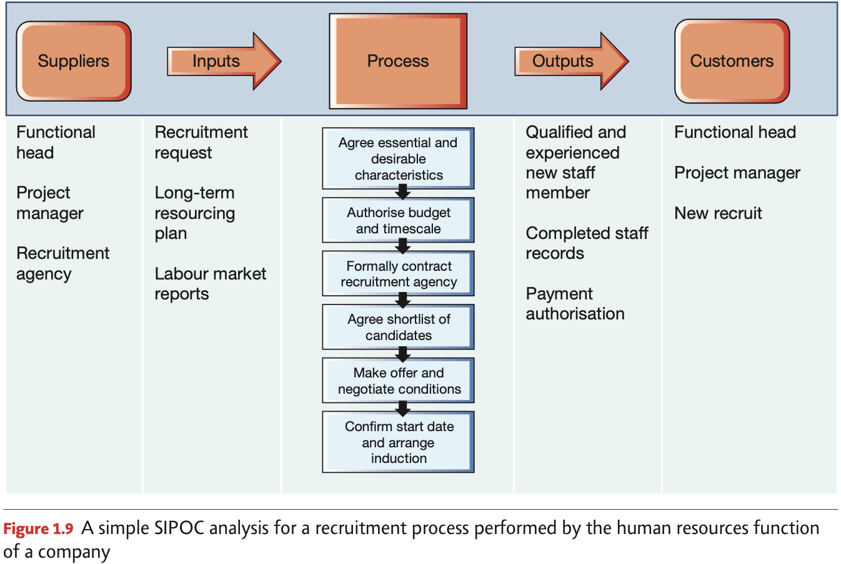

* 1. **What is the process hierarchy?**

All operations consist of a collection of processes (units or departments) interconnecting with each other to form an **internal network**

**A process** = arrangement of resources and activities that transform inputs into outputs that satisfy (internal or external) customer needs. Each process is an **internal supplier** and an **internal customer** for other processes. Within each process, there is another network of individual units of resource such as individual people and individual items of process technology (machines, storage facilities)

“Any business/operation is made up of a network of processes, any process is made up of a network of resources”

**Internal process** = model to analyze the internal activities of an operation. By treating internal customers with the same degree of care as external customers, the effectiveness of the whole operation can be improved

**Supply network** = Any operation could have several suppliers and several customers, and may be in competition with other operations creating similar services or products to itself

**Hierarchy of operations/process hierarchy** = analyze businesses at three levels: the process, the operation and the supply network

**Critics:** the idea of the internal network of process can be seen as over-simplistic. One cannot treat internal customers and suppliers exactly as one does external customers and suppliers since the latter operate in a free market (if an organization believes that in the long run it can get a better deal by purchasing services and products from another supplier it will do so, but internal customers cannot look outside to purchase input resources or to sell their output)

**Operations management is relevant to all parts of the business**

All functions of the organization have processes that need managing, each function has its technical knowledge (i.e. marketing expertise) and also have a **process management** role in producing its services

* 1. **How do operations (and processes) differ?**

All operation processes differ in a number of ways called **the four Vs**:

* **Volume** of their output
* **Variety** of their output
* **Variation** in the demand for their output
* **Degree of visibility** that the creation of their output has for customers

**The volume dimension**

**Volume** has important implications for the way operations are organized. For high volume, the **repeatability** of the tasks people do and the **systemization** of the work can use standard procedures to specify how each part of the job should be carried out. For low volume, the repetition will be lower and also the amount of staff which will perform a wider range of tasks.

**Systematized and repeated tasks** makes it worthwhile developing specialized machines to give low unit costs. Low repetition makes it less worth to invest in specialized equipment and the unit price is likely to be higher

**The variety dimension**

A high-variety service must be flexible and results in higher costs (more knowledge required) whilst a lower variety (less customization) needs less flexibility and can be standardized and regular resulting in lower costs

**The variation dimension**

Marked variation in demand means that the operation must change its capacity in some way. High variation in demand will result in high unpredicted costs. Level demand can plan its activities well in advance and results in a high utilization of resources and lower unit costs

**The visibility dimension**

**Visibility** = how much of the operation’s activities its customers experience, or how much the operation is exposed to its customers

**Customer-processing operations** are more exposed to their customers than material- or information processing operations.

A high visibility operation (for retailers) will conform most of the IHIP characteristics since customers will directly experience most of its value-adding activities and are likely to demand a short waiting time.

**High received variety** = when customers request services or products that clearly would not be sold in i.e. a shop

A low-contact operation with lower visbility can be more factory lag since the time lag between a order being placed and the items ordered by the customer being retrieved and dispatched doest not have to be minutes but can be hours or days – and can also have high staff utilization

**The implications of the four Vs of operations processes**

**Low processing costs** = high volume, low variety, low variation, low customer contact

**Processing cost penalty** = low volume, high variety, high variation, high customer contact

The position of an operation on the four dimensions is determined by the demands of the market it is serving

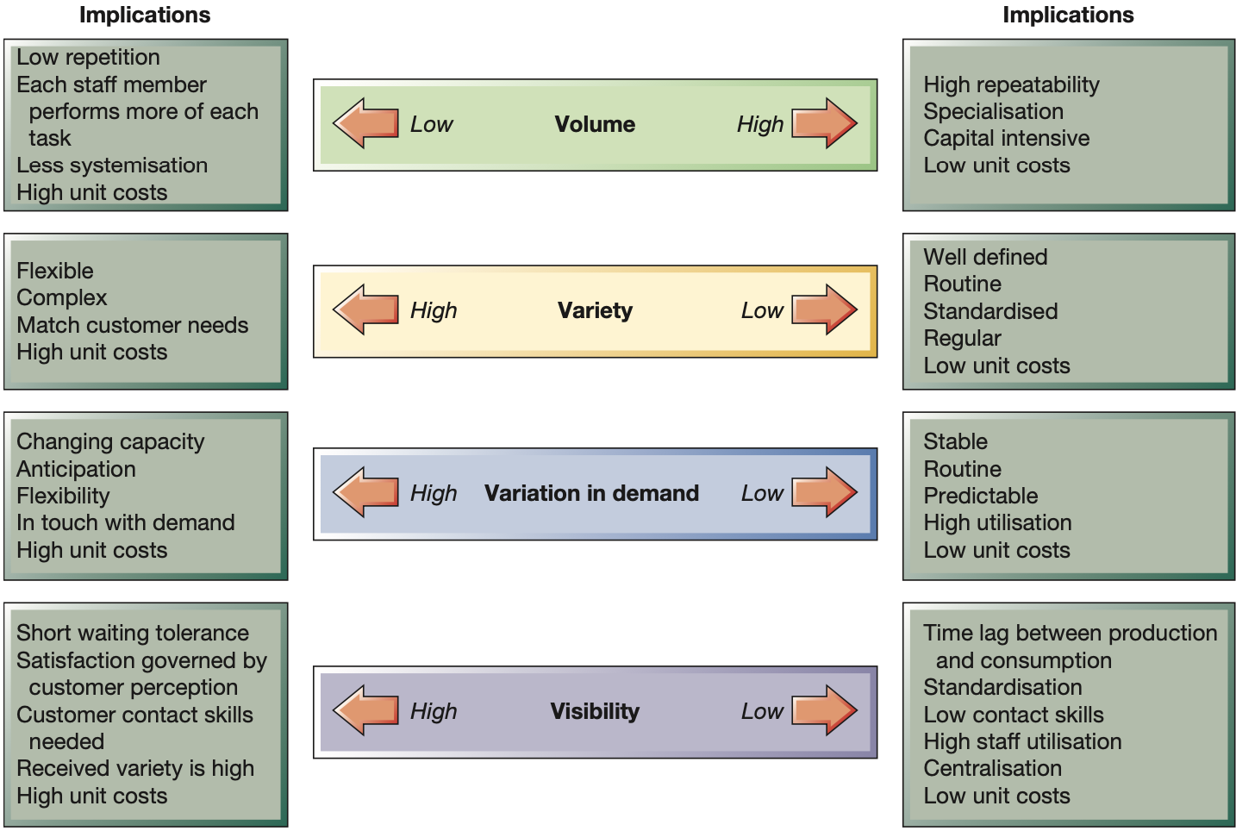

* 1. **What do operations managers do?**

Operations management activities are classified under: direct, design, deliver, develop:

* **Directing** the overall strategy of the operation
  + A general understanding of operations and processes and their strategic purpose and performance together with an appreciation of how strategic purpose is translated into reality – a prerequisite to the detailed design of operations and process
* **Designing** the operation’s services, products and processes
  + Design is the activity of determining the physical form, shape and composition of operations and processes together with the services and products that they create
* Planning and control process **delivery**
  + After being designed the delivery of services and products from suppliers and through the total operation to customers must be planned and controlled
* **Developing** process performance
  + Increasingly it is recognized that in operations, or any process, managers cannot simply deliver services and products routinely in the same way that they always have done. They have a responsibility to develop the capabilities of their processes to improve process performance

**Operations management impacts social-environmental sustainability**

**Social responsibility** = important to operations managers because of the profound impact operations practice can have on the environment and society at large, and conversely how operations practice is shaped by social-environmental considerations

**Environmental sustainability** = meeting the needs of the present without compromising the ability of future generations to meet their own needs. The extent to which business activity negatively impacts on the natural environment

**The model of operations management**

Operations and the processes that make up both the operations and other business functions are **transformation systems** that take in inputs and use process resources to transform them into outputs

Resources, both in an organization’s operations as a whole and in its individual processes, need to be managed in terms of how they are directed, designed, how delivery is planned and controlled, and how they are developed

